**openLISEM description**

openLISEM is a raster model that simulates the surface water balance and sediment balance in high spatial detail. The model is designed to simulate the effects of detailed land use changes or conservation measures on runoff, flooding and erosion during heavy rainstorms. It is a model designed to be used in disaster risk management, not for long term estimates. The model simulates interception by roofs and vegetation, a soil water balance, infiltration and ruinoff, and shallow flooding (see figure 1). It does not simulate ‘slower’ processes such as evapotranspiration, groundwater flow or changes in vegetation because of crop growth, so the initial values are important.

The model can handle any size catchment (the largest is several hundred km2 so far), but the grid cell size has to be smaller than 1 ha in order for certain process assumptions to be correct. Large areas also need correct input data such as spatially varying rainfall. openLISEM will run with practically any dataset, but that is not a guarantee for good results.

Emphasis is put on detail: characteristic about the model is the capacity to handle sub-gridcell surface properties. A gridcell can contain a bare soil, crusted/compacted soil, vegetated surface, a road, a house and a channel (see figure 2). These surface characteristics are supplied in separate layers as fractions: the base layer is formed by the soil surface with its hydrological characteristics and the user supplies additional maps that trigger additional hydrological processes in the model. For instance the presence of a vegetation will result in interception on a part of the gridcell, presence of a house in interception and a partly impermeable surface, a road will have no infiltration and erosion but can have sedimentation etc.

**Surface runoff and 1D flow**

Following a standard surface water balance, openLISEM first calculates the net precipitation by subtracting the actual interception storage, based on canopy storage functions as described in De Jong and Jetten (2007). Subsequently, the infiltration rate is calculated by a one-layer Green and Ampt, based on a direct use of the Darcy equation for one-dimensional flow (Kutílek and Nielsen, 1994). There is no need for an iterative estimation of time to ponding as the model timestep is very short (15 s). The infiltration rate q (in m/s) is calculated as:

equation (1)

with *K*sat the saturated hydraulic conductivity (m/s), *L* the depth of the wetting front (m) calculated as the cumulative infiltration (m) divided by the available soil storage (m3/m3), *h* the negative matrix suction at the wetting front (m) and *d* the overpressure depth of the water layer at the soil surface (m). The infiltration cannot exceed the soil depth in case of impermeable subsoils so that saturation overland flow is eventually generated when the soil storage is exceeded. The model considers different subpixel surfaces such as fraction of crusted, compacted or impenetrable surfaces, or grass strips, for which separate infiltration calculations can be performed. In case of runoff, openLISEM assumes that the micro-roughness causes not only surface storage (Kamphorst *et al.*, 2000) but also determines the flow width through a fraction of the grid cell that is ponded and hydraulic radius if there is ponding. The flow width is calculated form the surface roughness using the empirical equation (Jetten and De Roo, 2001):

equation (2)

with *w* flow width (m), *f*pa fraction of ponded area (−), *d* the depth of the runoff water (m) and *RR* the standard deviation of micro-roughness surface heights (m). Runoff water is routed with an implicit solution of the kinematic wave (Chow *et al.*, 1988). The kinematic wave is based on the velocity V (m/s), wich is calculated with the Manning’s equation:  
V = R2/3 * sqrt(S)/n (3)

In which R is the hydraulic radius (m), calculated with the flowwidth and average water height, S is  the terrain slope (sine) and n is a surface resistance parameter. The discharge Q (m3/s) per cell is then calculated with (Chow et al., 1988):  
Q = α·Aβ                              (4)  
α = [n/sqrt(S)·P2/3]β  
β = 0.6

in which A is the wet cross section (m2) and P is the wet perimeter (m). For the distributed overland and channel flow routing, an implicit, four-point finite-difference solution of the kinematic wave is used together with Manning’s equation. Procedures of the numerical solution can be found in Chow et al. (1988) and Moore & Foster (1990). The kinematic wave is done over the surface flow direction map (LDD = Local Drain Directions map) that forms a network which connects cells in 8 directions.

Some cells may have a channel (ditch, gully, river bed) for which a separate kinematic wave is done. The cells that have a channel receive a part of the overland flow, depending on the velocity. Thus the velocity is considered the average velocity existing in the cell. The channel is considered to be in the center of the cell so that the distance from the edge to the channel is 0.5*(DX-channelwidth). The fraction *f* of the water that flows into the channel is therefore:  
f = V·dt/(0.5·(DX-channelwidth))

In case of natural or artificial channels, the stream flow is routed with its own kinematic wave, determined by the channel dimensions, roughness and bed slope. Infiltration in channel beds is possible, but once water has entered a channel it cannot leave it, in other words there is no flooding possibility in openLISEM. It is important to note that the same equations are used for overland flow and for channel flow, where a separate stream power is calculated based on channel velocity and bed slope.

**Flooding from channels and 2D flow**

Flooding in openLISEM follows a 1D/2D approach. The order of processes is as follows. Runoff water is accumulated on a predefined flow network with a kinematic wave procedure. The flow network is provided by the user and is usually based on the flow direction in a 3x3 cell window following the steepest slope. The kinematic wave converges water to a single outflow point where it leaves the catchment. The kinematic wave is an iterative procedure using the user defined timestep of the model, which is usually in the order of 5-60 seconds. Furthermore it is possible to define a channel network, for manmade channels or natural riverbeds. In cells which contain a channel, part of the runoff water is diverted to the channel, and the channel captures rainfall directly. The amount of water reaching the channel depends on the runoff velocity, the timestep and the size of the gridcell compared to the channel size. The channel characteristics are defined by a series of maps for width, depth, bed slope angle, channel wall angle, manning’s n, and cohesion. The channel can be made impermeable or can infiltrate water. Once there is water in the channel, the kinematic wave is executed a second time for the channel alone, using a channel network map, to route the water to the outlet.

Finally, when the discharge wave reaches a height that is larger than the channel depth, the water overflows back onto the adjacent surface. Depending on the amount of overflow substantial flooding can take place. The flooding is done using an opensource “FullSWOF” method proposed by Delestre et al. (2009) (see <http://www.univ-orleans.fr/mapmo/soft/FullSWOF/#publi> ) based on the classical system of Saint-Venant equation for shallow water floods. The term shallow in this case refers to the assumption that the flooding can be estimated with on average flow velocity and does not need to take vertical velocity changes in to account. The method uses an explicit numerical solution with a varying timestep, where the timestep is adjusted to meet stability criteria. The method is fast and robust with a high precision. The flood module is executed as many timis as needed to “fill up” a LISEM time step. Typically a LISEM timestep is 10 seconds, while the flood module runs at timesteps fluctuate between 5 to 0.5 seconds (depending on the local circumstances). The timestep used for the entire flood domain is the smallest timestep occurring in the flood domain, so the gridcell with the smallest timestep determines the solution.

openLISEM is currently in a beta stage concerning this flood module. Both the kinematic wave and the fullswof method have very small mass balance eroors, but the coupling of the two methods in LISEM is still under construction. There are two coupling mechanisms:

1. It is assumed that the water in the channel cells themselves, instantaneously reaches an equilibrium between the water level in the channel and the flood water level in the strip of land adjacent to the channel. This assumes therefore that the channels are not too narrow compared to the cellsize and timestep. This resulting water level is then used to execute the flood module
2. It is assumed that runoff water reaching the flood boundary has some momentum and takes some time to mix. Water is turbulent everywhere (this has been checked with Reynolds numbers) and the turbulence together with the momentum causes a certain mixing distance. To simulate this additional friction during the mixing a simple assumption has been made: the manning’s n of the flooded area is temporarily increased, with a factor depending on the flood depth D (in m):

N_effective =n_local*exp(1.5*D)

Thus the kinematic wave for overland flow will change in the flood domain to have a rapid decrease of velocity where the flood water is deeper.

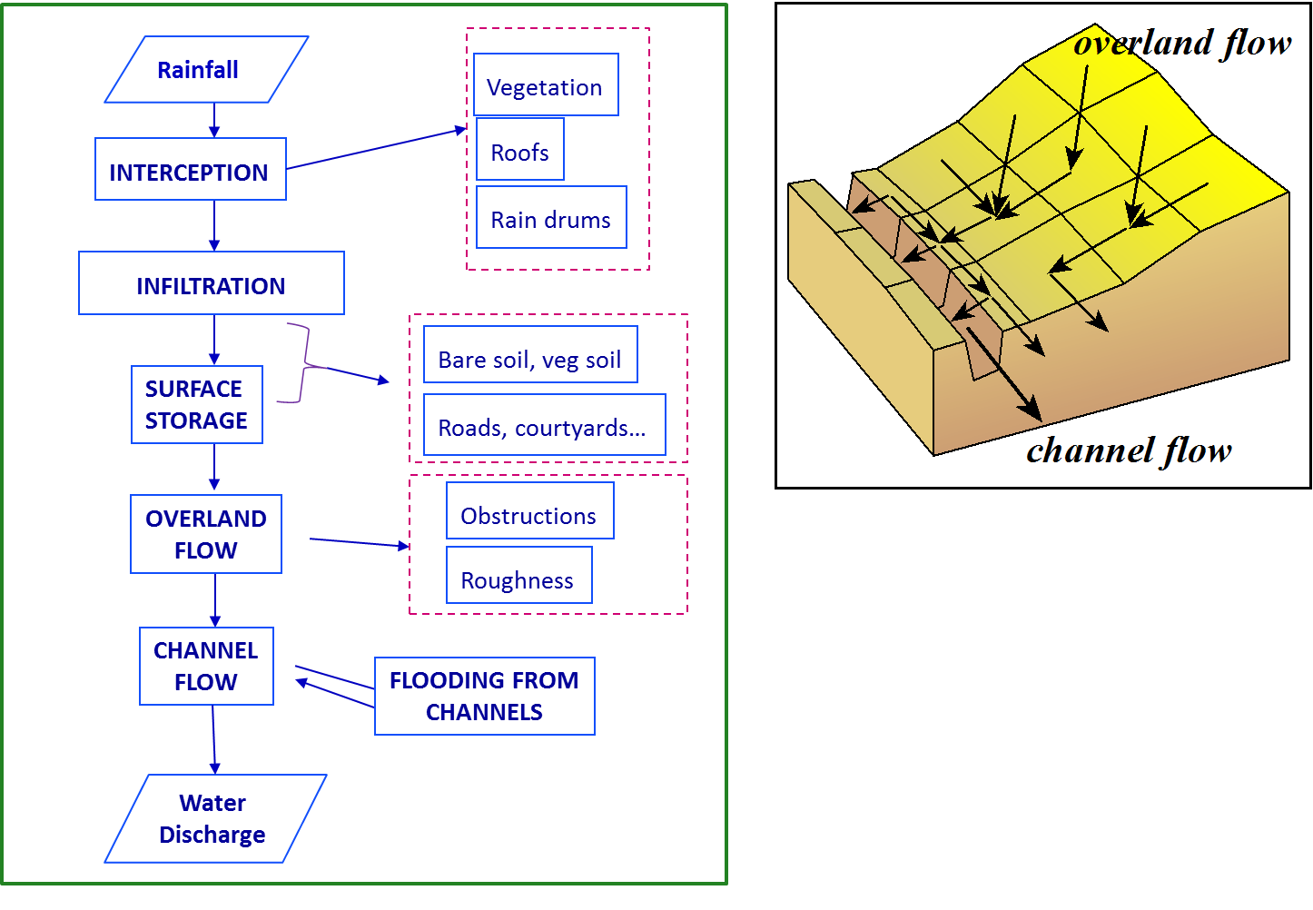

Figure 1. Flow chart of openLISEM with the main processes that are calculated for each timestep for each gridcell. The 3D image shows the 1D routing in a raster system over a predefined flow network.

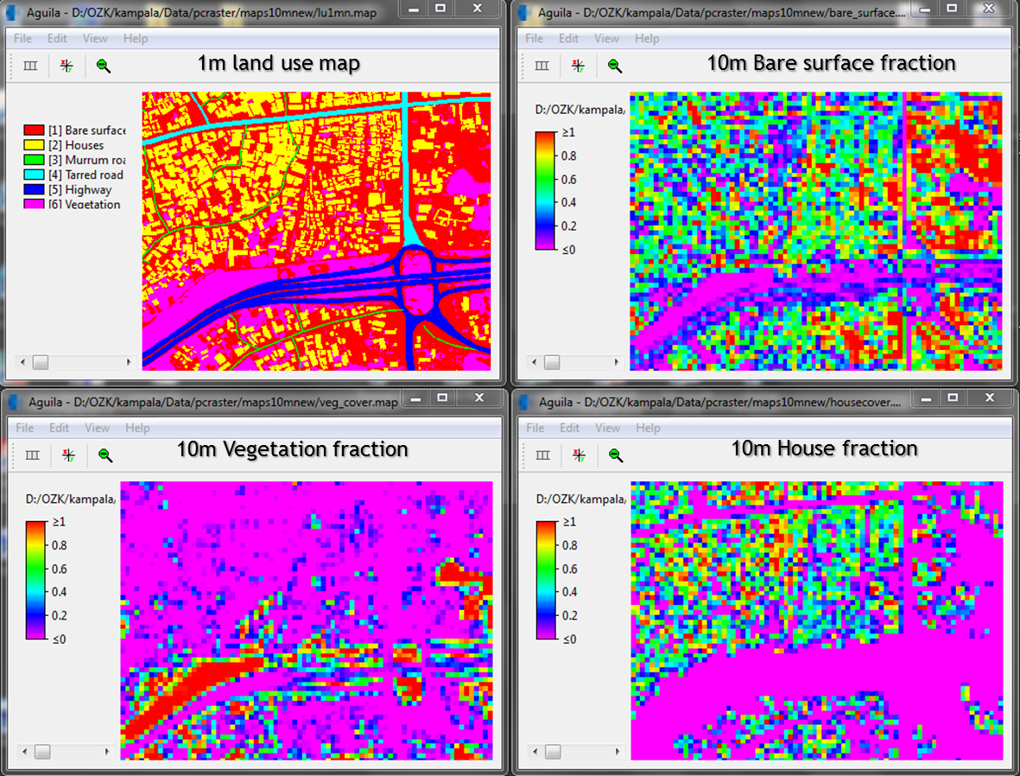

Figure 2. Sub-gridcell information with different surface available as fraction of the gridcell (10m): bare surface, vegetation and building fraction. Together they add up to 1 (100%). The upper left corner map shows the original 1m resolution map from which the fraction maps are derived.